**REPORT of Assignment Two**

**Content of the Report**

* **Introduction**
* **File Containing**
* **Test Plan**
* **Test Details**

**Introduction**

* This is the report of Assignment two in which an application is made to take the information about student, student’s year, subject, assessment and achievements. A student information can only be created by the authorized user. After creating the student information, we can load assessment and grade of the student to their corresponding subjects. Then we can display the assessments and display grades inside the application. Finally, we can terminate the program from application.

**File Containing**

This assignment submission contains the following file:

* Student.java - Source Code for the Student class
* Subject.java - Source Code for the Subject class
* Assessment.java - Source Code for the Assessment class
* DatabaseUtility.java - Source code for the programmatic operation of the database.
* StudyMonitorInterface.java – Source code for the GUI components, other required methods as outlined above and the main method.

The database has been created using MySQL for storing the student’s information.

**Test Plan:**

The following test has been shown through this report:

* Authentication of Admin
* Create Student
* Load Assessment
* Set Grade
* Save
* Display Assessment
* Display Grade
* Clear Display
* Exit

**Test Details:**

The following are details of the test plan.

* **Authentication of Admin:**

A authentication is done to check whether the given login info is correct. For this assignment, the login can be done by giving the Admin Name as ‘admin’ and password as ‘admin’. Press the login button for authentication.

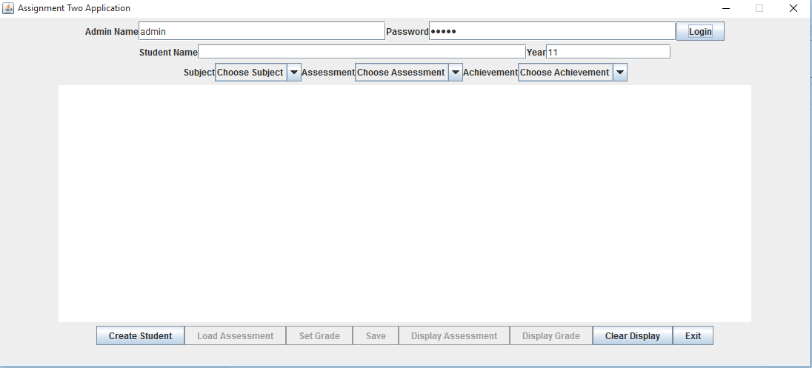

* **Create Student**

After authenticating the admin, ‘Create Student’ button is a enabled and it is used to add the student name and their year in the application by creating a student object. The subjects are also added while adding the student is being created. We can create multiple student for this application which are all saved in database.

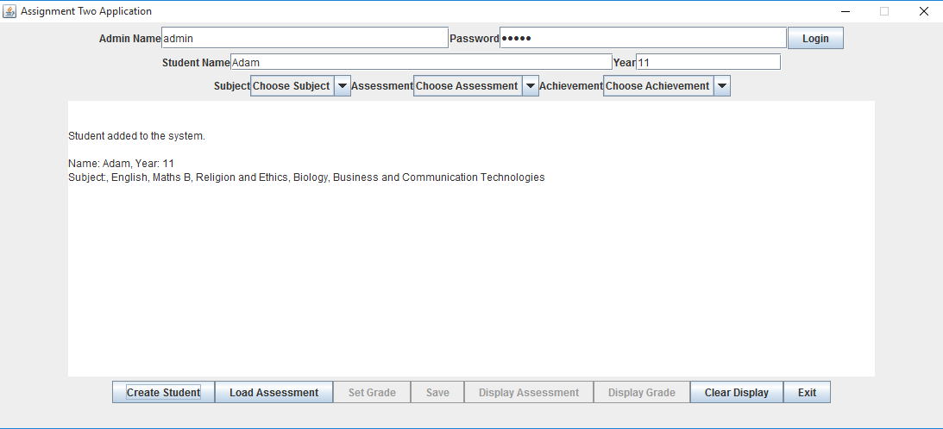

* **Load Assessment**

After creating student object, ‘Load Assessment’ button is enable to load the assessment for the subject of the student. This button reads the data from the datafile ‘data.csv’ and given assessment information to the application. Click the button to add the assessment to subject and also to populate the combox of Subject, Assessment and Achievement.

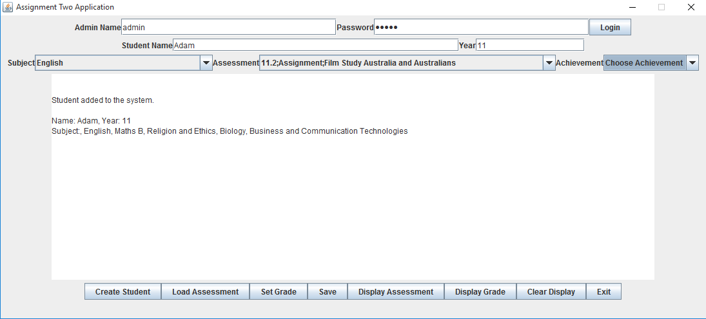

* **Set Grade**

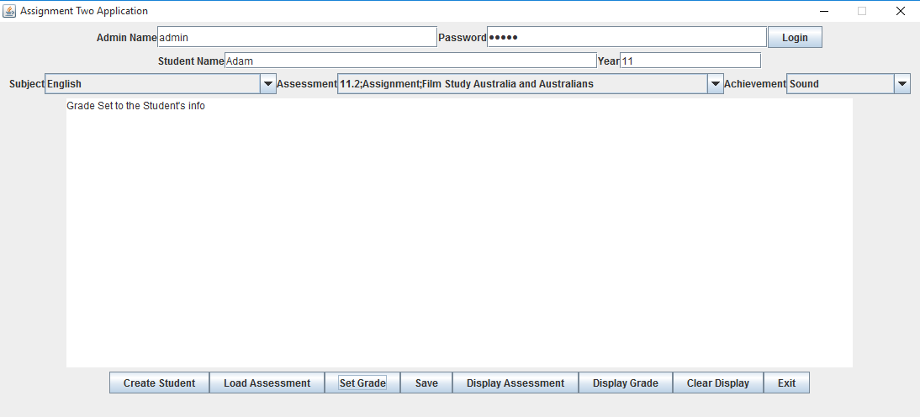‘Set Grade’ button is activated after ‘Load Assessment’ has been clicked. This button allows admin to set degree for the achievement for the chosen Assessment item, for chosen student and subject.

* **Save**

This button saves the entered Student data, subject, assessment details and grades to be saved to the database.

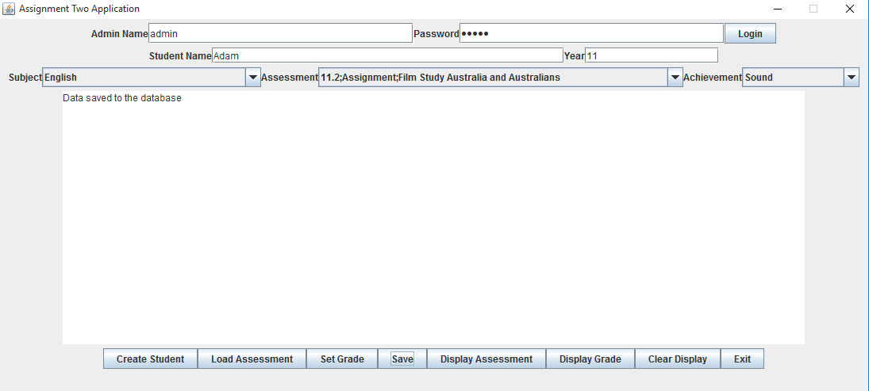

* **Display Assessment**

This button displays the assessment details of the chosen subject in the textarea and also shows whether it is graded or not.

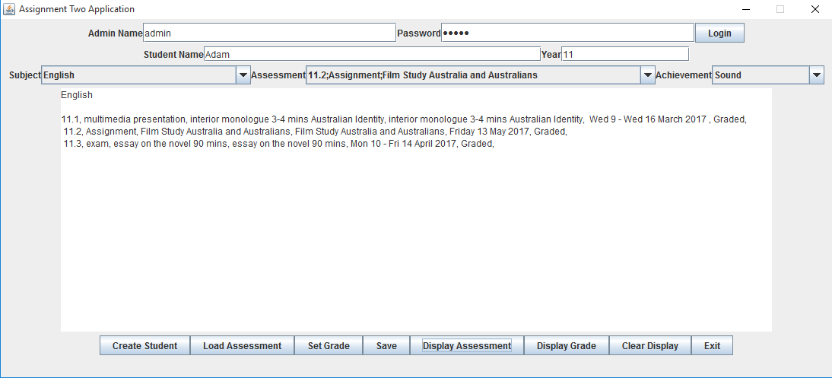

* **Display Grade**

‘Display Grade’ button displays the grade of the grades of the various assessment set already in the textarea. After adding assessment details to two subject, the following is the screenshot displaying the subject, assessment, achievement, skill and knowledge of the given student.

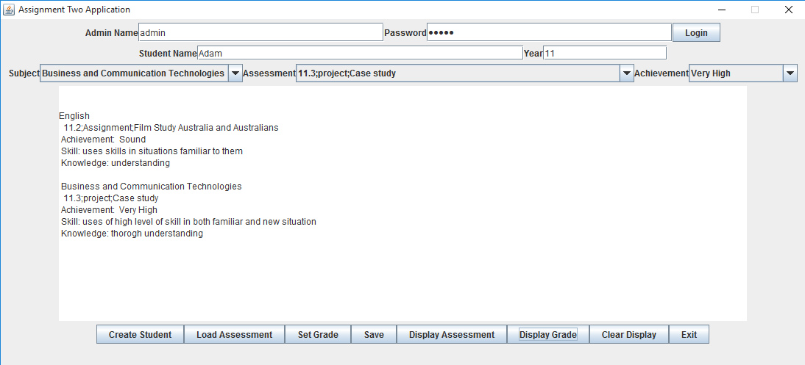

* **Clear Display**

‘Clear Display’ button clear the textarea and all the combox of Subject, Assessment and Achievement.

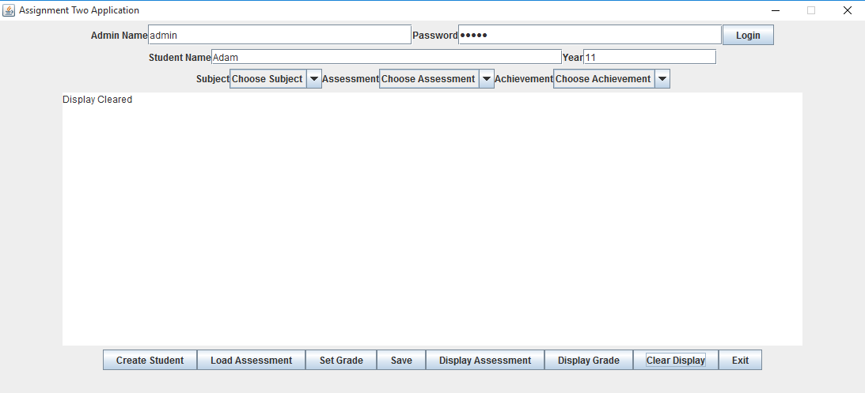

* **Exit**

‘Exit’ button exits the application.